

CSA0501-DATABASE MANAGEMENT SYSTEMS

LAB EXPERIMENTS DATE: 08/07/2026

EXPERIMENT 1 -- DDL Commands (CREATE, ALTER, DROP, TRUNCATE, RENAME)

AIM:
To create and manage the database structure for a Pet Management System using Data Definition Language (DDL) commands such as CREATE, ALTER, DROP, TRUNCATE, and RENAME.

PROCEDURE:
- Open MySQL and create the database for the Pet Management System.
- Use the CREATE command to create required tables such as Pets with suitable attributes and data types.
- Use the ALTER command to add, modify, or remove columns from an existing table.
- Use the RENAME command to change the name of an existing table.
- Use the TRUNCATE command to remove all records from a table while keeping its structure.
- Use the DROP command to permanently delete an unwanted table from the database.
- Use DESC table_name; or SHOW TABLES; after the operations to verify the changes.
- Execute each command and observe the output to ensure that all DDL operations are performed successfully.

PROGRAM:
- CREATE DATABASE

CREATE DATABASE Pet_Management;
Then select the database:

USE Pet_Management;

OUTPUT:
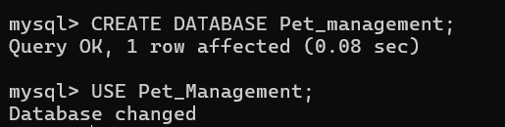

CREATE TABLE
CREATE TABLE Pets (
SNo INT PRIMARY KEY,
Pet_Name VARCHAR(50),
Pet_Breed VARCHAR(50),
Age VARCHAR(20),
Food VARCHAR(50),
Place VARCHAR(50),
Total INT
);
DESC Pets;

OUTPUT:

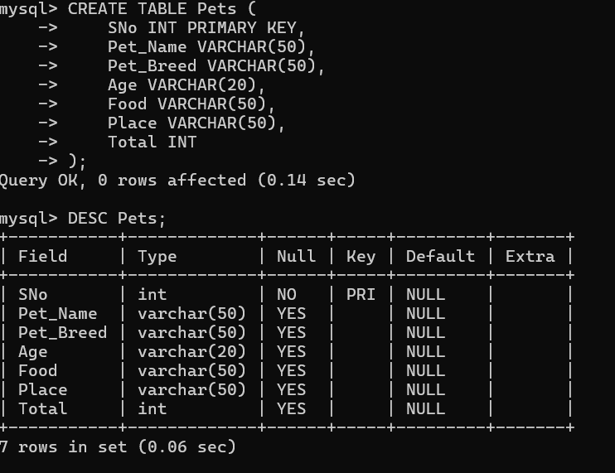

ALTER – ADD COLUMN

Add a new column called Vaccination_status:

ALTER TABLE Pets
ADD Vaccination_Status VARCHAR(20);

DESC Pets;

OUTPUT:
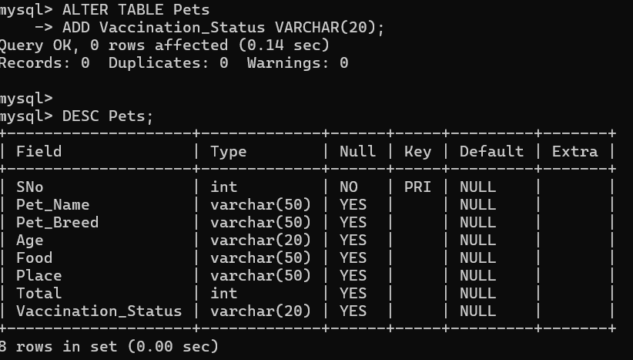

ALTER – MODIFY COLUMN
Change the size of Pet_Name:

ALTER TABLE Pets
MODIFY Pet_Name VARCHAR(100);

DESC Pets; 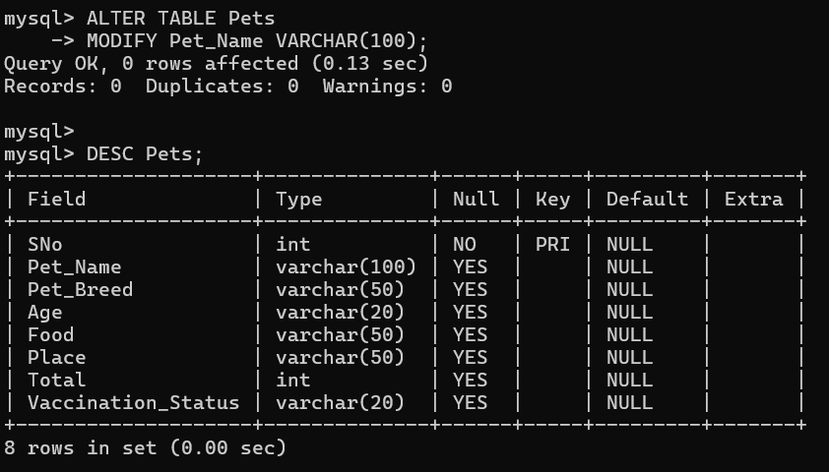

ALTER – DROP COLUMN
Remove the Vaccination_status column:

ALTER TABLE Pets
DROP COLUMN Vaccination_status; DESC Pets;

OUTPUT:

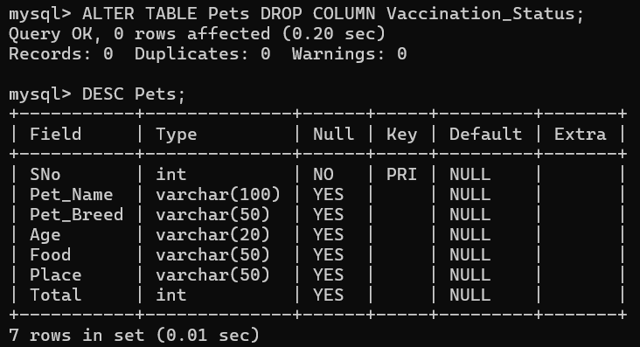

RENAME TABLE
Rename Pets to Pets_Details:

RENAME TABLE Pets TO Pets_Details;
SHOW TABLES;

OUTPUT:
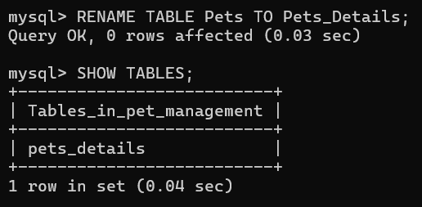

INSERT SAMPLE DATA
You need some data before testing TRUNCATE.

INSERT INTO Pets_Details (SNo, Pet_Name, Pet_Breed, Age, Food, Place, Total) VALUES

(1, 'Rudra', 'Lab', '3 months', 'Pedigree', 'Kuppam', 5),

(2, 'Snoopy', 'German Shepherd', '1 year', 'Pedigree', 'Rajamundry', 1),

(3, 'Chichu', 'Guinea Pig', '2 weeks', 'Vegetables', 'Chittoor', 6),

(4, 'Hulk', 'Tortoise', '1 month', 'Vegetables', 'Singapore', 3),

(5, 'Battu', 'Hen', '2 weeks', 'Rice', 'Chittoor', 10),

(6, 'Tiger', 'Pit Bull', '1 year', 'Nonveg', 'Chennai', 1),

(7, 'Luna', 'Cat', '6 weeks', 'Milk', 'Kuppam', 2),

(8, 'Shala', 'Betta Fish', '1 month', 'Fishfood', 'Pondicherry', 5),

(9, 'Tommy', 'Golden Retriever', '1 year', 'Pedigree', 'Chennai', 1),

(10, 'Hucky', 'Beagle', '1 year', 'Pedigree', 'KGF', 1);

SELECT * FROM Pets_Details;

OUTPUT:
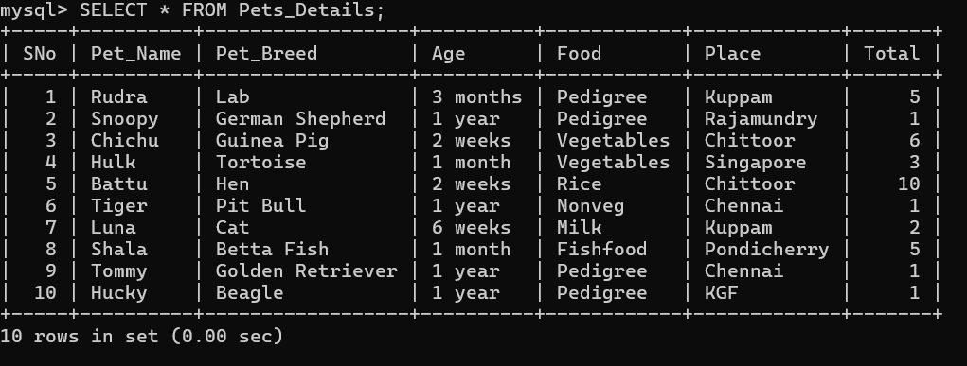

- TRUNCATE TABLE

TRUNCATE TABLE Pets_Details;
Check:

SELECT * FROM Pets_Details;

The table will be empty, but the table still exists.

OUTPUT:

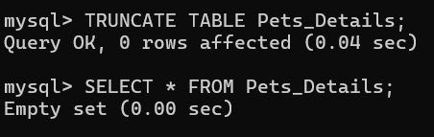

9.DROP TABLE
It completely removes the table.
DROP TABLE Pets_Details;
SHOW TABLES;

OUTPUT:
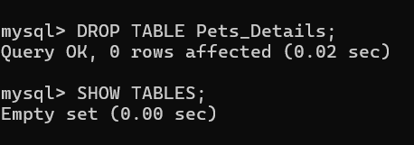

RESULT:
Thus the DDL commands executed successfully.

